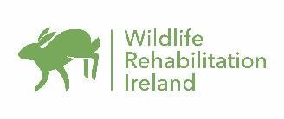
WRI Internship Application Form
Contact Details
Name
Address

Contact Number
Email address
Profession
Education
Current Studies  (or studies recently completed) | Course Name
 | Name and Address of School/University
Previous Education History

Other Experience and Trainings
Previous work experience/internships
Other courses/trainings relating to animal care, wildlife conservation or related fields.

Other courses/trainings (computer courses, health and safety, business etc.)
Languages& fluency
Full Driving Licence? | □ Yes □ No
Own car? | □ Yes □ No

Your Internship
What do you hope to gain from this internship position?
What is youravailability?Startand end date.
NB priority is given to those able to commit to a minimum of 3mths
Vaccinations | We advise you to consult your GP or health care provider for up-to-date information about vaccinations. Our advice on vaccinations and other medical matters can only be informal.

References
Please send us a reference with your application(not family or friends)
Please also provide contact details of the individualso we can contact them for more information should we need to do so
Name:
Contact number:
In what capacity do you know this person?

This is a full-timeunpaid position. Shared housing onsite will be offered to the successful applicant at a cost of 80 Euro/week (excluding food). The successful applicant will be responsible for their own travel expenses. Prior to your arrival date you must arrange a covid test and produce proof of having a negative result.

Name: Date:

